EL NIÑO/SOUTHERN OSCILLATION (ENSO) DIAGNOSTIC DISCUSSION

issued by

CLIMATE PREDICTION CENTER/NCEP/NWS

and the International Research Institute for Climate and Society

12 September 2019

ENSO Alert System Status: Not Active

Synopsis: ENSO-neutral is favored during the Northern Hemisphere fall 2019 (~75% chance), continuing through spring 2020 (55-60% chance).

During August, ENSO-neutral continued as reflected by near-average sea surface temperatures (SST) across most of the central and eastern equatorial Pacific Ocean (Fig. 1). The latest weekly Niño-3 and Niño-3.4 indices were -0.2°C and 0.0°C, respectively, with the westernmost Niño-4 region index remaining above average (0.5°C) and the easternmost Niño-1+2 region index remaining below average (-0.6°C; Fig. 2). Upper-ocean subsurface temperature anomalies (averaged across 180°-100°W) decreased slightly during the month (Fig. 3), with below-average temperatures strengthening in the east-central equatorial Pacific (Fig. 4). Suppressed tropical convection continued over parts of Indonesia, while near-average convection was evident near the Date Line (Fig. 5). Low-level and upper-level winds were near average over most of the tropical Pacific Ocean. Overall, oceanic and atmospheric conditions were consistent with ENSO-neutral.
The majority of models in the IRI/CPC plume (Fig. 6) continue to favor ENSO-neutral (Niño-3.4 index between -0.5°C and +0.5°C) through the Northern Hemisphere spring. Interestingly, the statistical model averages favor Niño-3.4 values above the El Niño threshold (+0.5°C) during the fall and winter, while the dynamical model average indicates values near +0.2°C. Forecasters are leaning toward the dynamical model average, which is also supported by the current tendency of the ocean toward cooler conditions. In summary, ENSO-neutral is favored during the Northern Hemisphere fall 2019 (~75% chance), continuing through spring 2020 (55-60% chance; click CPC/IRI consensus forecast for the chance of each outcome for each 3-month period).
This discussion is a consolidated effort of the National Oceanic and Atmospheric Administration (NOAA), NOAA’s National Weather Service, and their funded institutions. Oceanic and atmospheric conditions are updated weekly on the Climate Prediction Center web site (El Niño/La Niña Current Conditions and Expert Discussions). Forecasts are also updated monthly in the Forecast Forum of CPC's Climate Diagnostics Bulletin. Additional perspectives and analysis are also available in an ENSO blog. The next ENSO Diagnostics Discussion is scheduled for 10 October 2019. To receive an e-mail notification when the monthly ENSO Diagnostic Discussions are released, please send an e-mail message to: ncep.list.enso-update@noaa.gov.

Climate Prediction Center
National Centers for Environmental Prediction
NOAA/National Weather Service
College Park, MD 20740

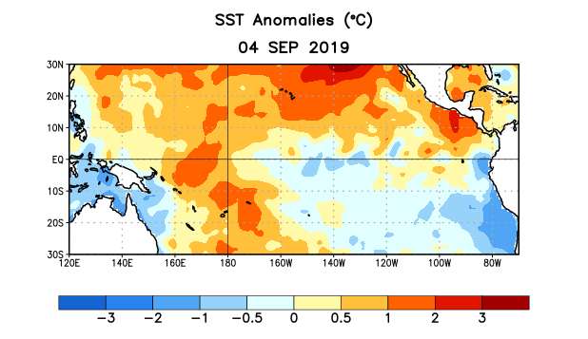
Figure 1. Average sea surface temperature (SST) anomalies (°C) for the week centered on 4 September 2019. Anomalies are computed with respect to the 1981-2010 base period weekly means.

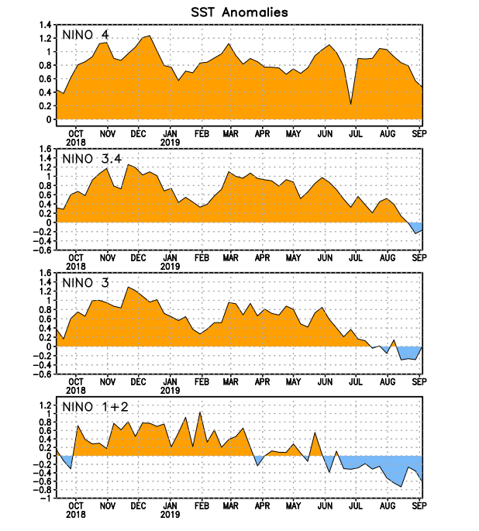
Figure 2. Time series of area-averaged sea surface temperature (SST) anomalies (°C) in the Niño regions [Niño-1+2 (0°-10°S, 90°W-80°W), Niño-3 (5°N-5°S, 150°W-90°W), Niño-3.4 (5°N-5°S, 170°W-120°W), Niño-4 (5ºN-5ºS , 150ºW-160ºE)]. SST anomalies are departures from the 1981-2010 base period weekly means.
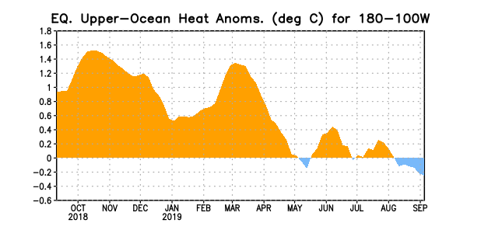
Figure 3. Area-averaged upper-ocean heat content anomaly (°C) in the equatorial Pacific (5°N-5°S, 180º-100ºW). The heat content anomaly is computed as the departure from the 1981-2010 base period pentad means.

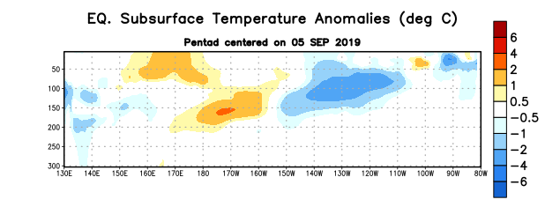
Figure 4. Depth-longitude section of equatorial Pacific upper-ocean (0-300m) temperature anomalies (°C) centered on the pentad of 5 September 2019. Anomalies are departures from the 1981-2010 base period pentad means.

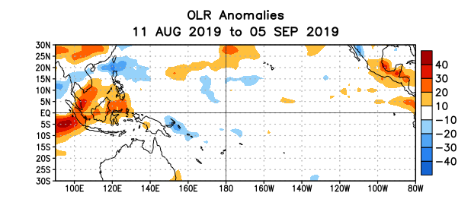
Figure 5. Average outgoing longwave radiation (OLR) anomalies (W/m²) for the period 11 August – 5 September 2019. OLR anomalies are computed as departures from the 1981-2010 base period pentad means.

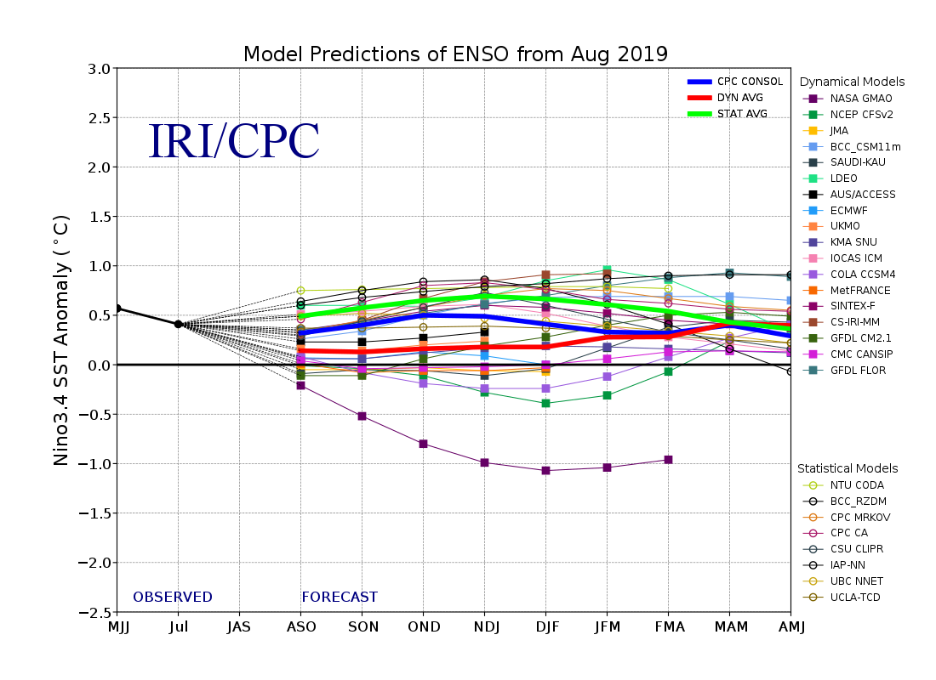
Figure 6. Forecasts of sea surface temperature (SST) anomalies for the Niño 3.4 region (5°N-5°S, 120°W-170°W). Figure updated 19 August 2019.

