EL NIÑO/SOUTHERN OSCILLATION (ENSO) DIAGNOSTIC DISCUSSION

issued by

CLIMATE PREDICTION CENTER/NCEP/NWS

and the International Research Institute for Climate and Society

10 September 2020

ENSO Alert System Status: La Niña Advisory

Synopsis: La Niña conditions are present and are likely to continue through the Northern Hemisphere winter (~75% chance).

In August, La Niña conditions were present, with below-average sea surface temperatures (SSTs) extending across the central and eastern equatorial Pacific Ocean (Fig. 1). In the last week, all Niño indices were negative, with the Niño-3.4 index at -0.9ºC and the Niño-1+2 and Niño-3 indices cooler than -1.0ºC (Fig. 2). Equatorial subsurface temperature anomalies averaged across 180°-100°W were negative (Fig. 3), with the largest departures observed in the east-central Pacific from the surface to 200m depth (Fig. 4). Atmospheric circulation anomalies over the tropical Pacific were also generally consistent with La Niña, despite sub-seasonal variability during the month. The low-level and upper-level winds were near average for the month as a whole, but enhanced low-level easterly winds were prominent across the equatorial Pacific Ocean during early and late August. Tropical convection remained suppressed over the western and central Pacific, and was near average over Indonesia (Fig. 5). Both the Southern Oscillation and Equatorial Southern Oscillation indices were positive. Overall, the coupled ocean-atmosphere system was consistent with La Niña conditions.
A majority of the models in the IRI/CPC plume predict the continuation of La Niña (Niño-3.4 index less than -0.5°C) through the Northern Hemisphere winter 2020-21 (Fig. 6). The forecaster consensus supports that view, and favors a borderline moderate event (Niño-3.4 index near -1.0ºC) during the peak November-January season. In summary, La Niña conditions are present and are likely to continue through the Northern Hemisphere winter (~75% chance; click CPC/IRI consensus forecast for the chance of each outcome for each 3-month period).
This discussion is a consolidated effort of the National Oceanic and Atmospheric Administration (NOAA), NOAA’s National Weather Service, and their funded institutions. Oceanic and atmospheric conditions are updated weekly on the Climate Prediction Center web site (El Niño/La Niña Current Conditions and Expert Discussions). Forecasts are also updated monthly in the Forecast Forum of CPC's Climate Diagnostics Bulletin. Additional perspectives and analysis are also available in an ENSO blog. The next ENSO Diagnostics Discussion is scheduled for 8 October 2020. To receive an e-mail notification when the monthly ENSO Diagnostic Discussions are released, please send an e-mail message to: ncep.list.enso-update@noaa.gov.

Climate Prediction Center
National Centers for Environmental Prediction
NOAA/National Weather Service
College Park, MD 20740

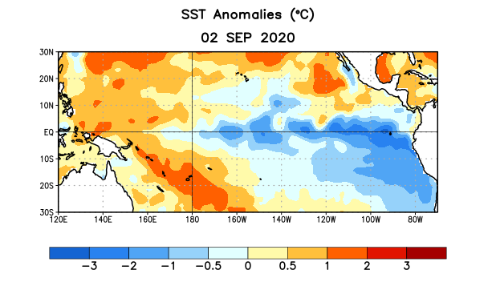
Figure 1. Average sea surface temperature (SST) anomalies (°C) for the week centered on 2 September 2020. Anomalies are computed with respect to the 1981-2010 base period weekly means.

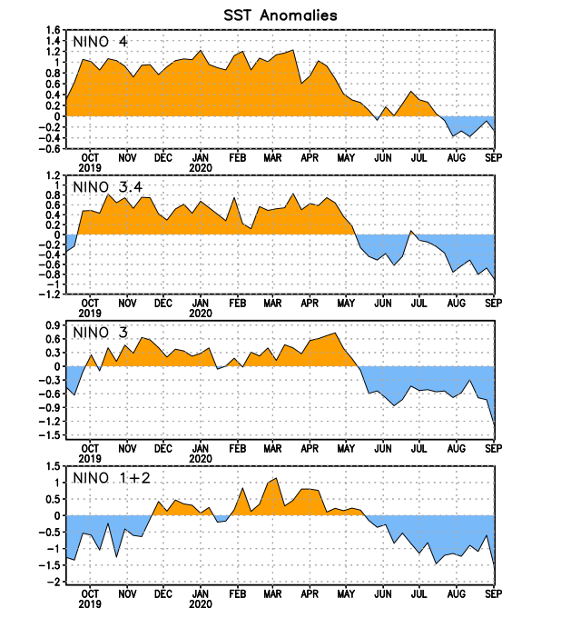
Figure 2. Time series of area-averaged sea surface temperature (SST) anomalies (°C) in the Niño regions [Niño-1+2 (0°-10°S, 90°W-80°W), Niño-3 (5°N-5°S, 150°W-90°W), Niño-3.4 (5°N-5°S, 170°W-120°W), Niño-4 (5ºN-5ºS , 150ºW-160ºE)]. SST anomalies are departures from the 1981-2010 base period weekly means.
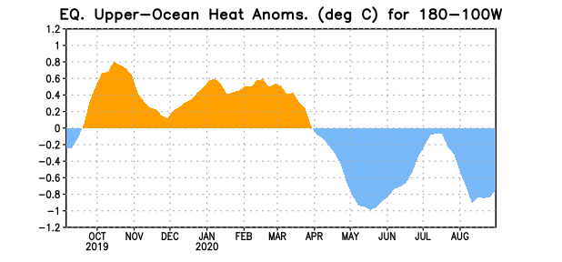
Figure 3. Area-averaged upper-ocean heat content anomaly (°C) in the equatorial Pacific (5°N-5°S, 180º-100ºW). The heat content anomaly is computed as the departure from the 1981-2010 base period pentad means.

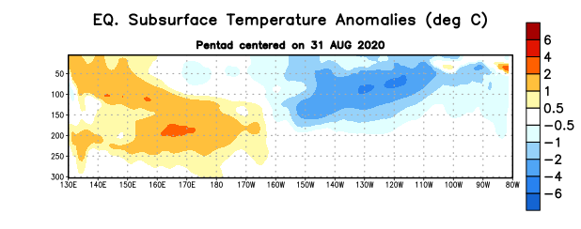
Figure 4. Depth-longitude section of equatorial Pacific upper-ocean (0-300m) temperature anomalies (°C) centered on the pentad of 31 August 2020. Anomalies are departures from the 1981-2010 base period pentad means.

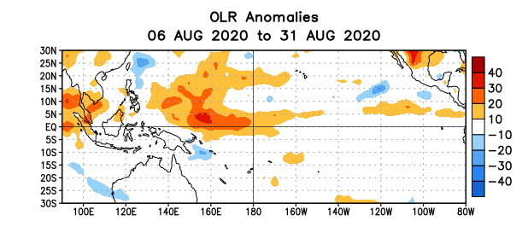
Figure 5. Average outgoing longwave radiation (OLR) anomalies (W/m²) for the period 6 – 31 August 2020. OLR anomalies are computed as departures from the 1981-2010 base period pentad means.

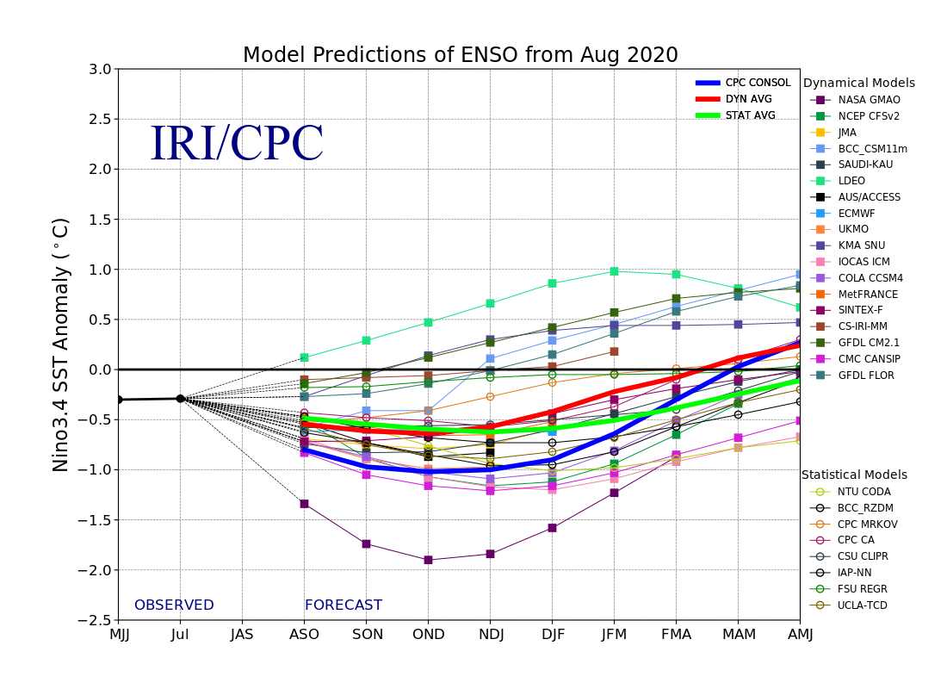
Figure 6. Forecasts of sea surface temperature (SST) anomalies for the Niño 3.4 region (5°N-5°S, 120°W-170°W). Figure updated 19 August 2020.

