EL NIÑO/SOUTHERN OSCILLATION (ENSO) DIAGNOSTIC DISCUSSION

issued by

CLIMATE PREDICTION CENTER/NCEP/NWS

and the International Research Institute for Climate and Society

9 September 2021

ENSO Alert System Status: La Niña Watch

Synopsis: A transition from ENSO-neutral to La Niña is favored in the next couple of months, with a 70-80% chance of La Niña during the Northern Hemisphere winter 2021-22.

In the last month, ENSO-neutral continued with near-to-below average sea surface temperatures (SSTs) persisting in the central and eastern equatorial Pacific (Fig. 1). In the last week, all of the Niño index values ranged from -0.2ºC to -0.3ºC (Fig. 2). Negative subsurface temperature anomalies (averaged from 180-100ºW) remained steady in August (Fig. 3), reflecting below-average temperatures that extended from the surface to ~250m depth in the eastern Pacific Ocean (Fig. 4). Low-level wind anomalies were easterly over the western Pacific Ocean, while upper-level wind anomalies were westerly over the western and east-central Pacific. Tropical convection was suppressed near and west of the Date Line and enhanced over Indonesia (Fig. 5). Given these conditions, the ocean-atmosphere system reflected ENSO-neutral, but is edging toward La Niña.
The IRI/CPC plume average of forecasts for the Niño-3.4 SST region from the last month favored borderline or weak La Niña during the fall and winter 2021-22 (Fig. 6). The forecaster consensus this month, however, favors the latest predictions from the NCEP CFSv2 and the North American Multi-Model Ensemble, which suggest higher chances for the emergence of La Niña. At this time, forecasters anticipate La Niña to be of weak strength (seasonal average Niño-3.4 index values between -0.5ºC to -0.9ºC). In summary, a transition from ENSO-neutral to La Niña is favored in the next couple of months, with a 70-80% chance of La Niña during the Northern Hemisphere winter 2021-22 (click CPC/IRI consensus forecast for the chances in each 3-month period).
This discussion is a consolidated effort of the National Oceanic and Atmospheric Administration (NOAA), NOAA’s National Weather Service, and their funded institutions. Oceanic and atmospheric conditions are updated weekly on the Climate Prediction Center web site (El Niño/La Niña Current Conditions and Expert Discussions). Additional perspectives and analysis are also available in an ENSO blog. A probabilistic strength forecast is available here. The next ENSO Diagnostics Discussion is scheduled for 14 October 2021. To receive an e-mail notification when the monthly ENSO Diagnostic Discussions are released, please send an e-mail message to: ncep.list.enso-update@noaa.gov.

Climate Prediction Center
National Centers for Environmental Prediction
NOAA/National Weather Service
College Park, MD 20740

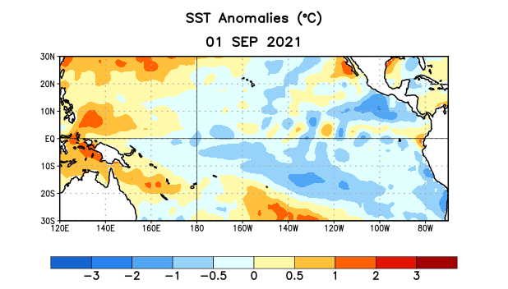
Figure 1. Average sea surface temperature (SST) anomalies (°C) for the week centered on 1 September 2021. Anomalies are computed with respect to the 1991-2020 base period weekly means.

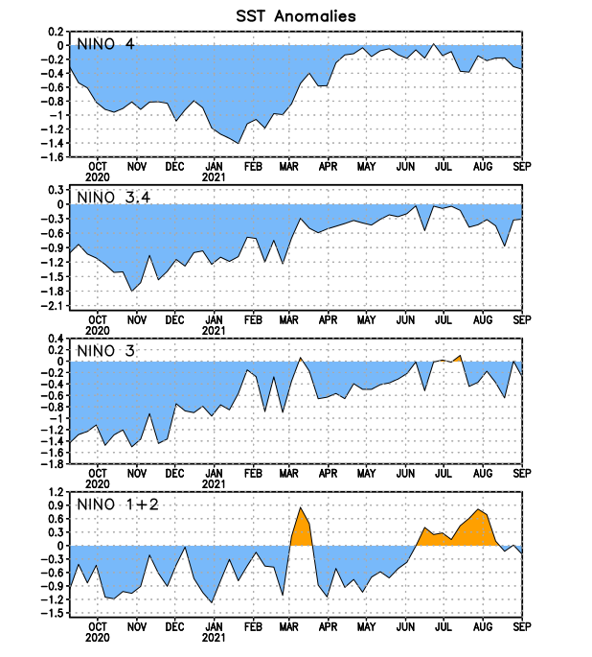
Figure 2. Time series of area-averaged sea surface temperature (SST) anomalies (°C) in the Niño regions [Niño-1+2 (0°-10°S, 90°W-80°W), Niño-3 (5°N-5°S, 150°W-90°W), Niño-3.4 (5°N-5°S, 170°W-120°W), Niño-4 (5ºN-5ºS, 150ºW-160ºE)]. SST anomalies are departures from the 1991-2020 base period weekly means.
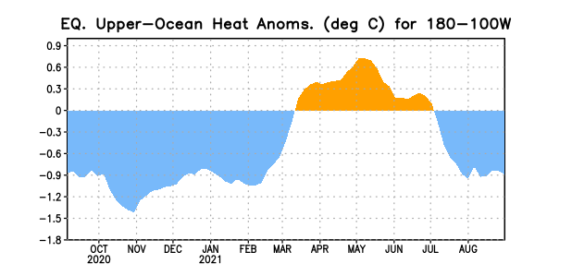
Figure 3. Area-averaged upper-ocean heat content anomaly (°C) in the equatorial Pacific (5°N-5°S, 180º-100ºW). The heat content anomaly is computed as the departure from the 1991-2020 base period pentad means.

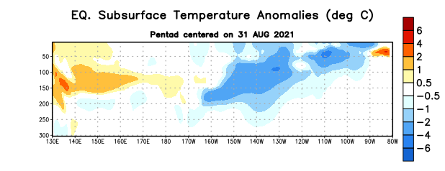

Figure 4. Depth-longitude section of equatorial Pacific upper-ocean (0-300m) temperature anomalies (°C) centered on the pentad of 31 August 2021. Anomalies are departures from the 1991-2020 base period pentad means.

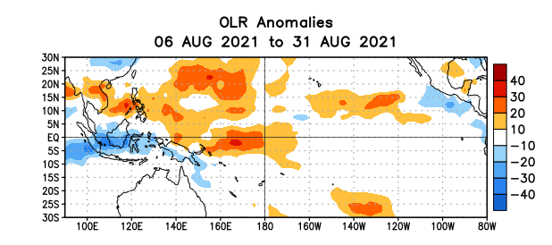
Figure 5. Average outgoing longwave radiation (OLR) anomalies (W/m²) for the period 6 – 31 August 2021. OLR anomalies are computed as departures from the 1991-2020 base period pentad means.

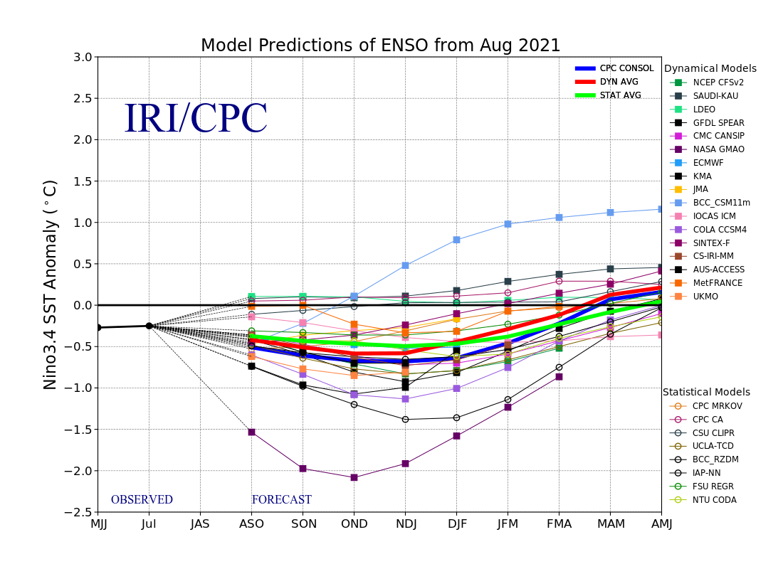
Figure 6. Forecasts of sea surface temperature (SST) anomalies for the Niño 3.4 region (5°N-5°S, 120°W-170°W). Figure updated 19 August 2021.

