EL NIÑO/SOUTHERN OSCILLATION (ENSO) DIAGNOSTIC DISCUSSION

issued by

CLIMATE PREDICTION CENTER/NCEP/NWS

8 September 2022

ENSO Alert System Status: La Niña Advisory

Synopsis: La Niña is favored to continue through Northern Hemisphere winter 2022-23, with a 91% chance in September-November, decreasing to a 54% chance in January-March 2023.

During August, below-average sea surface temperatures (SSTs) persisted across the central and east-central equatorial Pacific Ocean (Fig. 1). The largest SST anomalies were evident in the Niño-3.4 and Niño-4 regions, with the latest weekly values reaching -0.8ºC and -1.1ºC, respectively (Fig. 2). Negative subsurface temperature anomalies were mostly unchanged during the month (Fig. 3), reflecting the dominance of below-average temperatures across the eastern Pacific Ocean (Fig. 4). Low-level easterly wind anomalies and upper-level westerly wind anomalies continued across most of the equatorial Pacific. Convection and rainfall remained suppressed over the western and central tropical Pacific and enhanced over Indonesia (Fig. 5). Overall, the coupled ocean-atmosphere system continued to reflect La Niña.
The most recent IRI plume forecast of the Niño-3.4 SST index indicates La Niña will persist into the Northern Hemisphere winter 2022-23 (Fig. 6). There is an interesting split in the dynamical versus statistical model forecasts, with the latter set suggesting La Niña will persist longer, through January-March 2023. At this time, the forecaster consensus sides with the statistical models, although there is still large uncertainty over how long La Niña will last and when it will transition to ENSO-neutral (56% chance of a transition to ENSO-neutral during February-April 2023). In summary, La Niña is favored to continue through Northern Hemisphere winter 2022-23, with a 91% chance in September-November, decreasing to a 54% chance in January-March 2023 (Fig. 7).
This discussion is a consolidated effort of the National Oceanic and Atmospheric Administration (NOAA), NOAA’s National Weather Service, and their funded institutions. Oceanic and atmospheric conditions are updated weekly on the Climate Prediction Center web site (El Niño/La Niña Current Conditions and Expert Discussions). Additional perspectives and analysis are also available in an ENSO blog. A probabilistic strength forecast is available here. The next ENSO Diagnostics Discussion is scheduled for 13 October 2022. To receive an e-mail notification when the monthly ENSO Diagnostic Discussions are released, please send an e-mail message to: ncep.list.enso-update@noaa.gov.

Climate Prediction Center
National Centers for Environmental Prediction
NOAA/National Weather Service
College Park, MD 20740

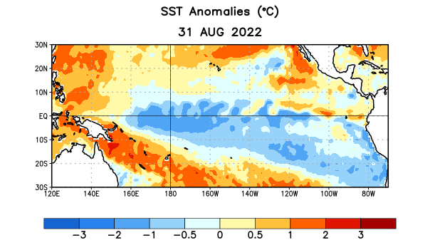
Figure 1. Average sea surface temperature (SST) anomalies (°C) for the week centered on 31 August 2022. Anomalies are computed with respect to the 1991-2020 base period weekly means.

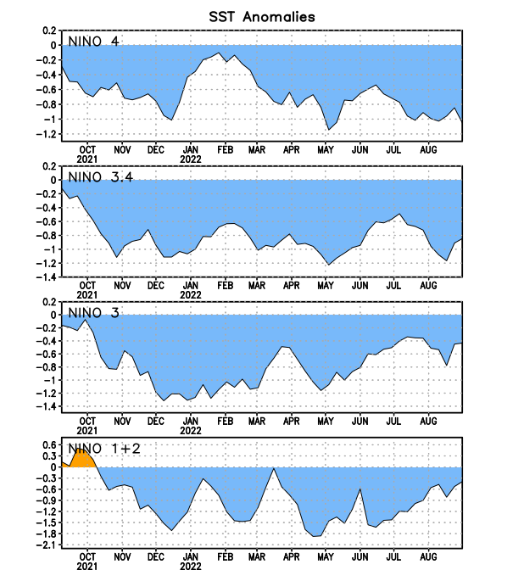
Figure 2. Time series of area-averaged sea surface temperature (SST) anomalies (°C) in the Niño regions [Niño-1+2 (0°-10°S, 90°W-80°W), Niño-3 (5°N-5°S, 150°W-90°W), Niño-3.4 (5°N-5°S, 170°W-120°W), Niño-4 (5ºN-5ºS, 150ºW-160ºE)]. SST anomalies are departures from the 1991-2020 base period weekly means.

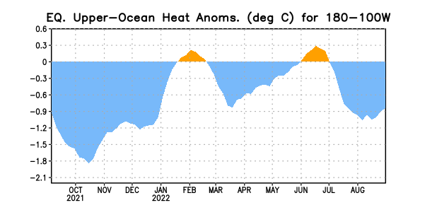

Figure 3. Area-averaged upper-ocean heat content anomaly (°C) in the equatorial Pacific (5°N-5°S, 180º-100ºW). The heat content anomaly is computed as the departure from the 1991-2020 base period pentad means.

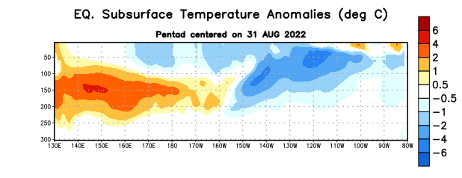

Figure 4. Depth-longitude section of equatorial Pacific upper-ocean (0-300m) temperature anomalies (°C) centered on the pentad of 31 August 2022. Anomalies are departures from the 1991-2020 base period pentad means.

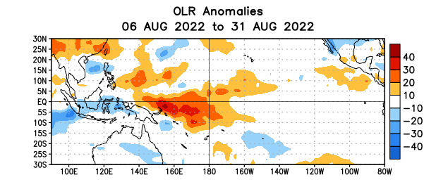

Figure 5. Average outgoing longwave radiation (OLR) anomalies (W/m²) for the period 6 – 31 August 2022. OLR anomalies are computed as departures from the 1991-2020 base period pentad means.

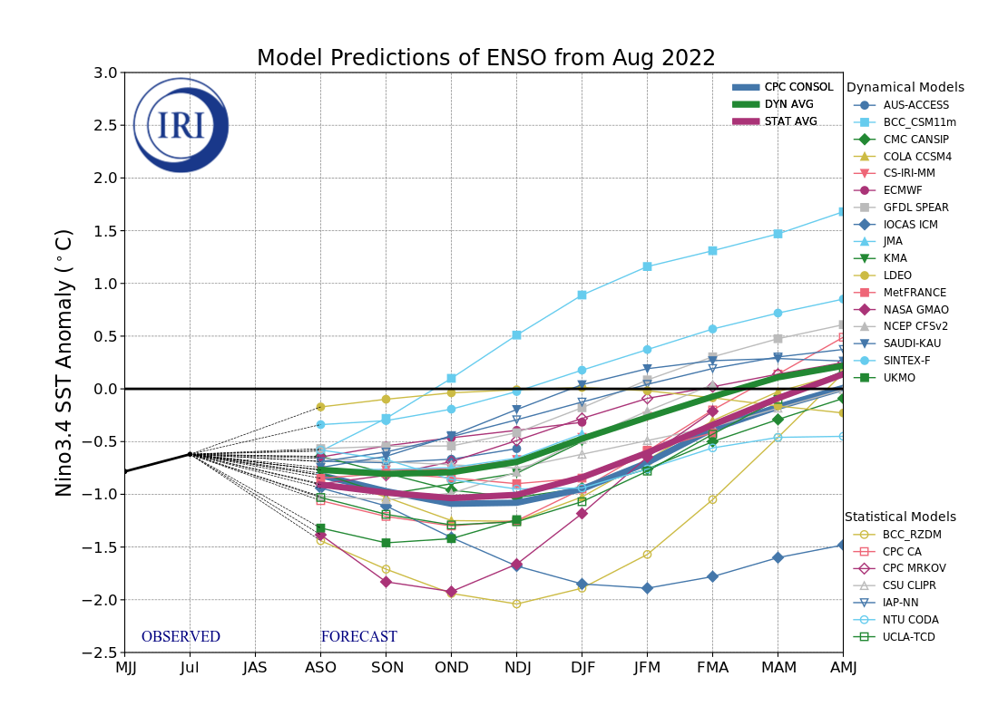
Figure 6. Forecasts of sea surface temperature (SST) anomalies for the Niño 3.4 region (5°N-5°S, 120°W-170°W). Figure updated 19 August 2022 by the International Research Institute (IRI) for Climate and Society.
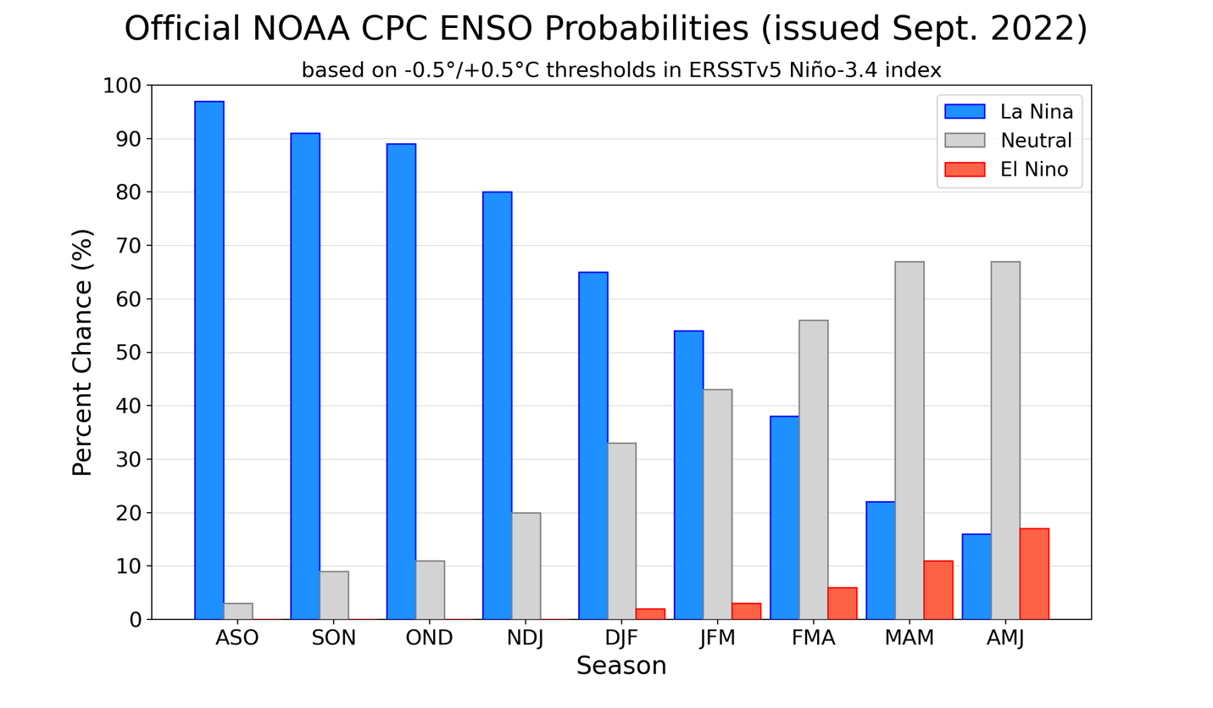
Figure 7. Official ENSO probabilities for the Niño 3.4 sea surface temperature index (5°N-5°S,
120°W-170°W). Figure updated 8 September 2022.

