EL NIÑO/SOUTHERN OSCILLATION (ENSO) DIAGNOSTIC DISCUSSION

issued by

CLIMATE PREDICTION CENTER/NCEP/NWS

14 September 2023

ENSO Alert System Status: El Niño Advisory

Synopsis: El Niño is anticipated to continue through the Northern Hemisphere winter (with greater than 95% chance through January - March 2024).

In August, sea surface temperatures (SSTs) were above average across the equatorial Pacific Ocean (Fig. 1), with strengthening in the central and east-central Pacific. All of the latest weekly Niño indices were in excess of +1.0ºC: Niño-4 was +1.1ºC, Niño-3.4 was +1.6ºC, Niño-3 was +2.2ºC, and Niño1+2 was +2.9ºC (Fig. 2). Area-averaged subsurface temperatures anomalies increased compared to July (Fig. 3) in association with anomalous warmth in the central and eastern equatorial Pacific Ocean (Fig. 4). Tropical atmospheric anomalies were also consistent with El Niño. Over the east-central Pacific, low-level winds were anomalously westerly, while upper-level winds were anomalously easterly. Convection was slightly enhanced around the International Date Line, stretching into the eastern Pacific, just north of the equator. Convection was mostly suppressed around Indonesia (Fig. 5). The equatorial Southern Oscillation Index (SOI) and the traditional station-based SOI were both significantly negative. Collectively, the coupled ocean-atmosphere system reflected El Niño.
The most recent IRI plume indicates El Niño will persist through the Northern Hemisphere winter 2023-24 (Fig. 6). Despite nearly the same ensemble mean amplitude as last month, the shorter forecast horizon means that the odds of at least a “strong” El Niño (≥1.5°C for the November-January seasonal average in Niño-3.4) have increased to 71%. However, a strong El Niño does not necessarily equate to strong impacts locally, with the odds of related climate anomalies often lower than the chances of El Niño itself (e.g., CPC’s seasonal outlooks). In summary, El Niño is anticipated to continue through the Northern Hemisphere winter (with greater than 95% chance through January - March 2024; Fig. 7).
This discussion is a consolidated effort of the National Oceanic and Atmospheric Administration (NOAA), NOAA’s National Weather Service, and their funded institutions. Oceanic and atmospheric conditions are updated weekly on the Climate Prediction Center website (El Niño/La Niña Current Conditions and Expert Discussions). Additional perspectives and analyses are also available in an ENSO blog. A probabilistic strength forecast is available here. The next ENSO Diagnostics Discussion is scheduled for 12 October 2023. To receive an e-mail notification when the monthly ENSO Diagnostic Discussions are released, please send an e-mail message to: ncep.list.enso-update@noaa.gov.

Climate Prediction Center
National Centers for Environmental Prediction
NOAA/National Weather Service
College Park, MD 20740
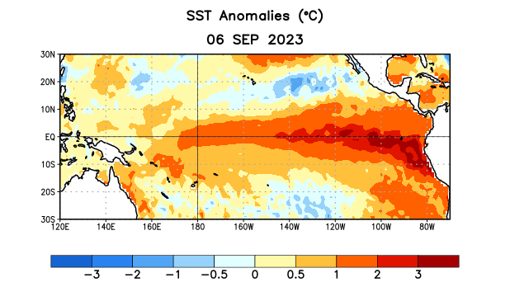
Figure 1. Average sea surface temperature (SST) anomalies (°C) for the week centered on 6 September 2023. Anomalies are computed with respect to the 1991-2020 base period weekly means.

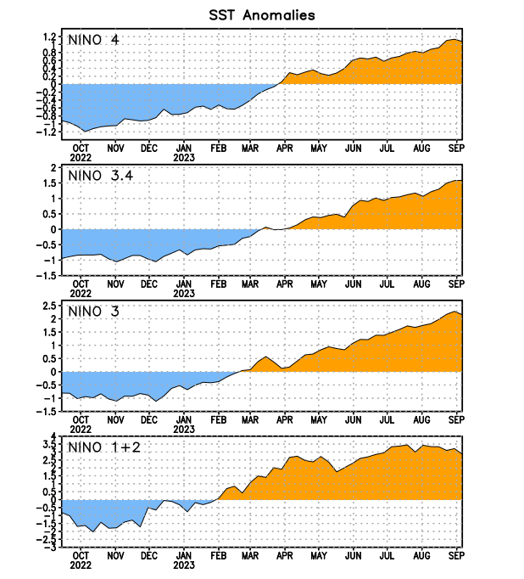
Figure 2. Time series of area-averaged sea surface temperature (SST) anomalies (°C) in the Niño regions [Niño-1+2 (0°-10°S, 90°W-80°W), Niño-3 (5°N-5°S, 150°W-90°W), Niño-3.4 (5°N-5°S, 170°W-120°W), Niño-4 (5ºN-5ºS, 150ºW-160ºE)]. SST anomalies are departures from the 1991-2020 base period weekly means.

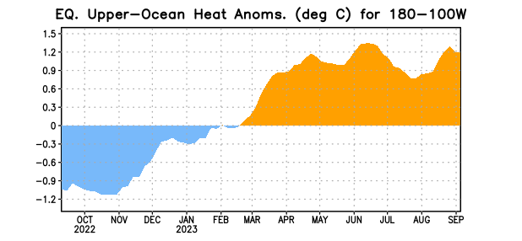

Figure 3. Area-averaged upper-ocean heat content anomaly (°C) in the equatorial Pacific (5°N-5°S, 180º-100ºW). The heat content anomaly is computed as the departure from the 1991-2020 base period pentad means.

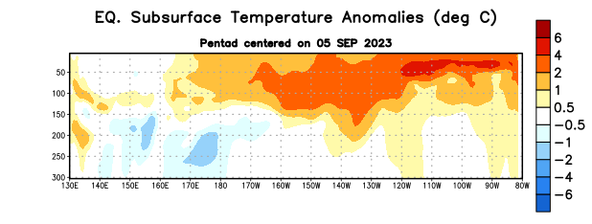
Figure 4. Depth-longitude section of equatorial Pacific upper-ocean (0-300m) temperature anomalies (°C) centered on the pentad of 5 September 2023. Anomalies are departures from the 1991-2020 base period pentad means.

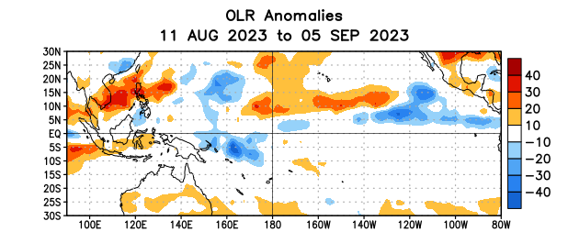

Figure 5. Average outgoing longwave radiation (OLR) anomalies (W/m²) for the period 11 August – 5 September 2023. OLR anomalies are computed as departures from the 1991-2020 base period pentad means.

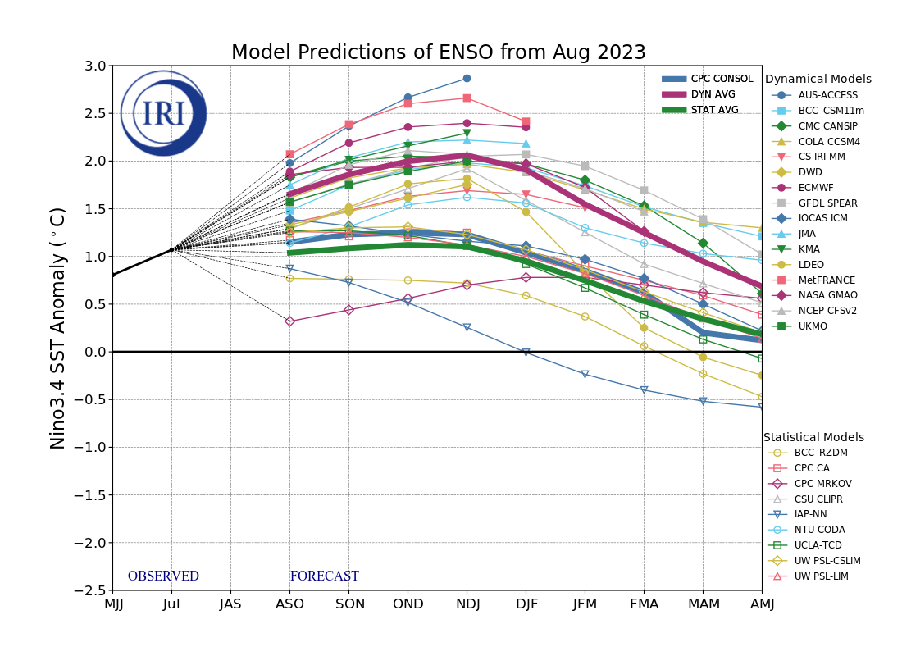
Figure 6. Forecasts of sea surface temperature (SST) anomalies for the Niño 3.4 region (5°N-5°S, 120°W-170°W). Figure updated 19 August 2023 by the International Research Institute (IRI) for Climate and Society.
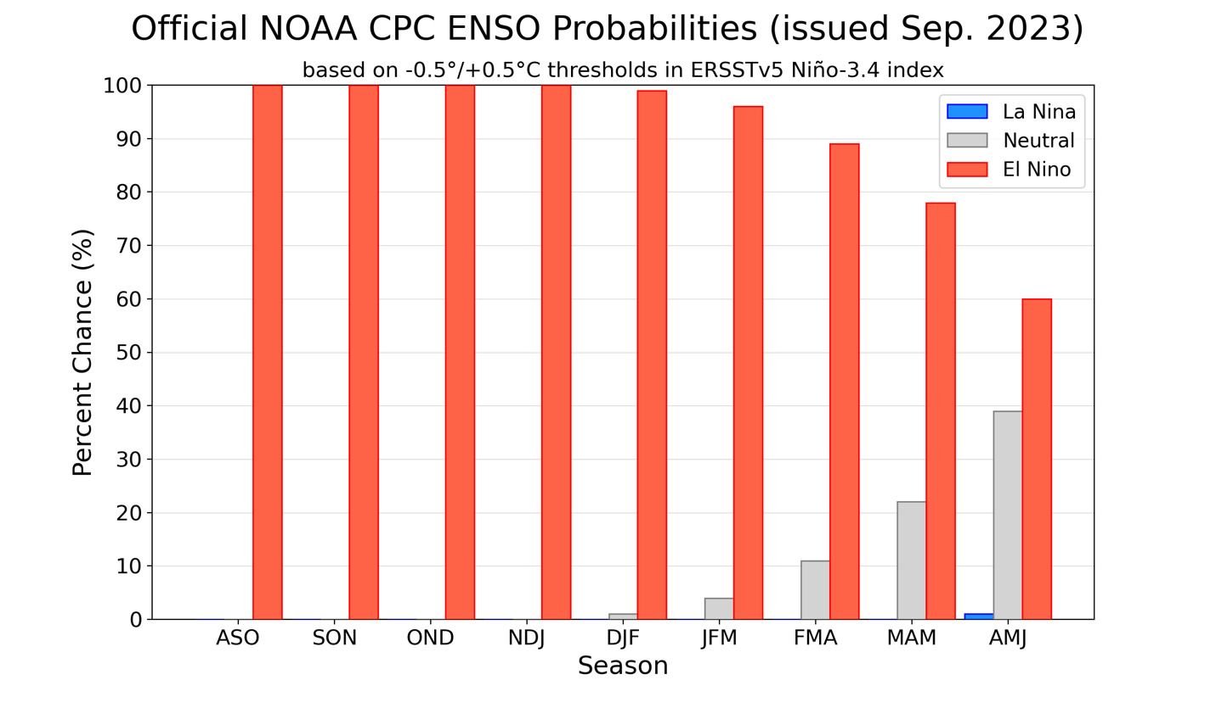
Figure 7. Official ENSO probabilities for the Niño 3.4 sea surface temperature index (5°N-5°S, 120°W-170°W). Figure updated 14 September 2023.

