New SST Climatology for the 1981-2010 Base Period
Jan. 18, 2011

A new sea surface temperature (SST) climatology for the 1981-2010 base period was constructed. The new climatology was constructed by merging monthly SST fields of ERSST.v3b (hereafter ERSST, Smith et al., 2008) for 1981 with OI.v2 SST (hereafter OISST, Reynolds et al., 2002) for 1982-2010. The OISST has a high temporal (weekly) and spatial (1-degree grid) resolution and is derived by combining in situ and satellite observations for the period of November 1981 to present. The ERSST is a monthly SST analysis on a 2-degree grid derived from in situ SST observations alone for the period of 1854 to present. At Climate Prediction Center (CPC), NCEP/NOAA, the OISST is used to monitor the current evolutions of El Niño/ Southern Oscillation (ENSO) events (http://www.cpc.ncep.noaa.gov/products/precip/CWlink/MJO/enso.shtml) and global SST modes (see CPC’s Monthly Ocean Briefing at http://www.cpc.ncep.noaa.gov/products/GODAS). However, to characterize ENSO events before 1981, the ERSST is used (http://www.cpc.ncep.noaa.gov/products/analysis_monitoring/ensostuff/ensoyears.shtml).

For 1981, the ERSST on a 2-degree grid was interpolated to a 1-degree grid to be compatible with the 1-degree OISST. Considering differences between the means of ERSST and OISST, ERSST anomaly in 1981 is first derived by removing its own climatology for the 1971-2000 base period, and then is interpolated into a 1-degree grid. The total ERSST is recovered by adding back the 1-degree 1971-2000 climatology, which was derived by combining 2-degree ERSST climatology for 1971-2000 and 1-degree OISST climatology for 1982-2000 (Xue et al., 2003). The 1-degree ERSST in 1981 is then combined with the 1-degree OISST in 1982-2010. The monthly SST climatology for 1981-2010 is simply calculated as average of monthly fields for each calendar month over the 30 years. The daily SST climatology is calculated by interpolating monthly fields of the climatology into daily fields. For leap years, the value on February 29 is the same as that on February 28.

From the 1971-2000 to 1981-2010 base periods, the seasonal mean SST in February-April increased by more than 0.2ºC over much of the Tropical Oceans and North Atlantic, but decreased by more than 0.2ºC in high-latitude North Pacific, Gulf of Mexico and along the east coast of U.S. (Fig. 1a). Compared to the spring season, the fall season (August-October) has a stronger warming in the tropical North Atlantic, North Pacific and Arctic Ocean, and a weaker cooling in Gulf of Mexico and along the east coast of U.S. (Fig. 1b). The plot of SST climatology differences for each calendar month and the plot for climatology NINO indices can be downloaded at http://origin.cpc.ncep.noaa.gov/products/people/yxue/sstclim.

The new SST climatology, in binary format, can be downloaded from the same web site. The binary data can be read with fortran code (read.f) or Grads scripts using corresponding .ctl files:

Monthly climatology:
ersst_oisst_1x1_clim_81-10.dat; ersst_oisst_1x1_clim_81-10.ctl

Daily climatology:
ersst_oisst_1x1_clim_81-10.daily.365.dat; ersst_oisst_1x1_clim_81-10.daily.365.ctl;
ersst_oisst_1x1_clim_81-10.daily.366.dat; ersst_oisst_1x1_clim_81-10.daily.366.ctl

Questions can be sent to Yan Xue at yan.xue@noaa.gov.

References:

Reynolds, R. W., N. A. Rayner, T. M. Smith, D. C. Stokes and W. Wang, 2002: An improved in situ and satellite SST analysis for climate. J. Climate, 15, 1609-1625.
Smith, T.M., R. W. Reynolds, T. C. Peterson, and J. Lawrimore, 2008: Improvements to NOAA’s historical merged land-ocean surface temperature analysis (1880-2006). J. Climate, 21, 2283-2296.
Xue, Y., T. M. Smith, and R. W. Reynolds, 2003: Interdecadal changes of 30-yr SST normals during 1871-2000. J. Climate, 16,1601-1612.

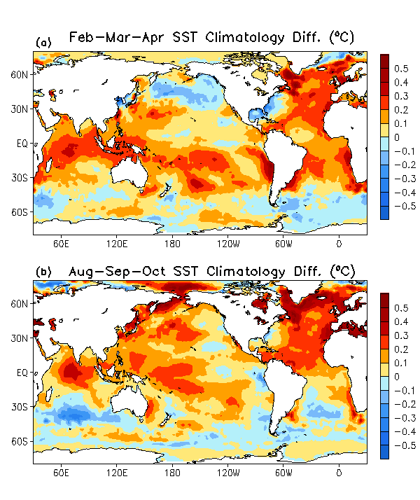
Figure 1. SST climatology differences between the 1981-2010 and 1971-2000 base period for (a) February-March-April, and (b) August-September-October seasonal means.

